Maven (apache)

Maven is basically a build tool (like ant, gradle) which is used to resolve the following problems that arise during the development of any project.

Common problems of projects

1. Multiple jars – when project is developed on some framework says spring then it require certain jars during compile time and deployment time. Maven does this for us.
2. Dependency and version – Many jars have dependency on one another, maven resolve those dependencies.
3. Project structure – it helps in maintaining the correct directory structure for example for some web application we need to have WEB-INF, libraries.
4. Build, publish and deploy

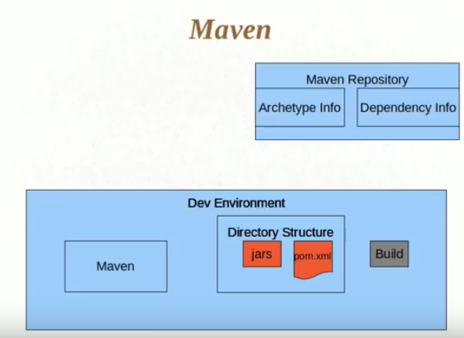

## How it works

Suppose we have to create a project based on maven archetype then first create a folder and inside a folder say mvn archetype:generate

Now this will show deferent archetypes and you can choose from there. Based on the chosen archetype, maven will create the folder structure also it will automatically download all the depending jars from maven repository.

Archetype – These represent the project model (ex. normal java project, spring, struts, hibernate project) and based on selection it creates the standard directory structure automatically

## POM.xml

It’s like a configuration file for maven where all the jar dependencies, folder structure, information required to build the code, scope, project packaging are define defined.

Here

**group id** = package name(com.core.packagename)

**artifact id** = project name

**packaging** = jar,war,ear( based on project chose during archetype)

If you want to include new jar dependency(ex. Log4j) here in pom then search for pom repository dependency in Google for log4j and copy paste that dependency code block below.

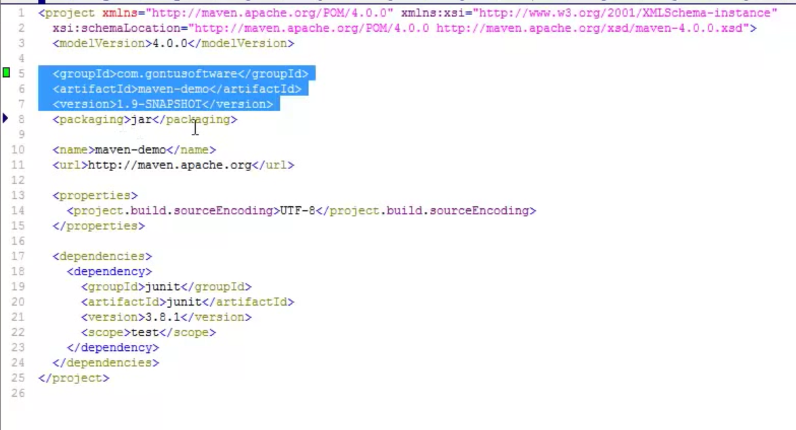

**PMD (Programmatic mistake detector)** – This is automatic software which we plugin in pipeline second project(after checkout) to check the mistakes done by developer in code (like empty catch block etc.)

**Junit** - This is plugged in to do the junit testing after PMD build

**Coberture** – It checks the java project after Junit to test how much code is access by unit test